Chapter 4 Continuous Variables and Their Probability Distributions

* 4.2 The Probability Distribution for a Continuous Random Variable

*Let Y denote any random variable. The* ***distribution function of Y*** *, or* ***cumulative distribution function****, denoted by F(y), is such that F(y) = P(Y ≤ y) for −∞ < y < ∞.*

*Distribution functions for discrete random variables are always* ***step functions*** *because the cumulative distribution function increases only at the finite or countable number of points with positive probabilities.*

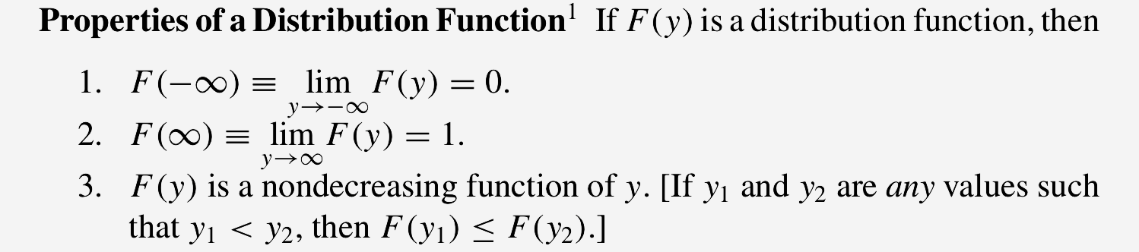

*A random variable Y with distribution function F(y) is* ***continuous*** *if F(y) is continuous, for −∞ < y < ∞.*

Note that if Y is a continuous random variable, then for any real number y, P(Y = y) = 0.

*Let F(y) be the distribution function for a continuous random variable Y. Then f (y), given by*

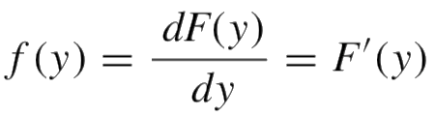

*wherever the derivative exists, is called the* ***probability density function*** *for the random variable Y .*

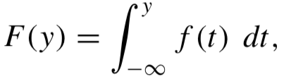

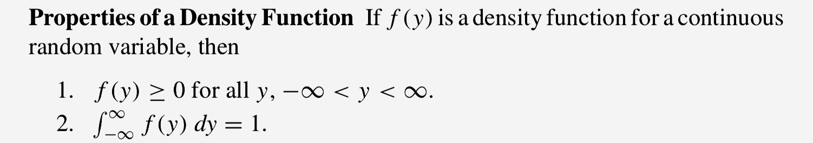

*Let Y denote any random variable. If 0 < p < 1, the pth* ***quantile*** *of Y, denoted by φp, is the smallest value such that P(Y ≤ φq) = F(φp) ≥ p. If Y is continuous, φp is the smallest value such that F(φp) = P(Y ≤ φp) = p. Some prefer to call φp the 100pth* ***percentile*** *of Y.*

Note that if p = 1/2, and φ.5 is the **median** of the random variable Y.

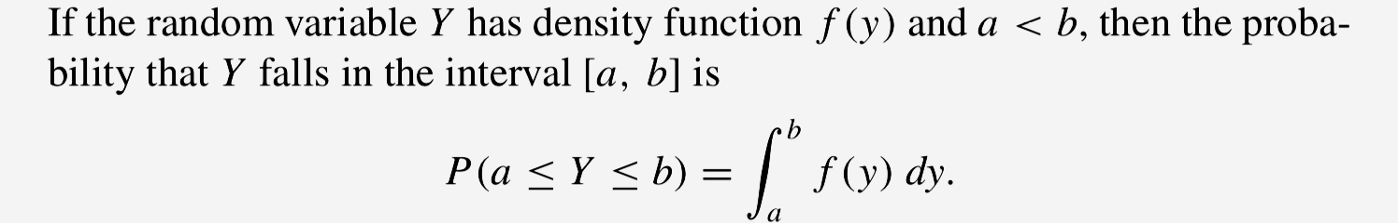

* 4.3 Expected Values for Continuous Random Variables

*The expected value of a continuous random variable Y is*

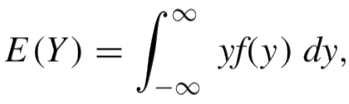

*provided that the integral exists.*

<Theorem 1>

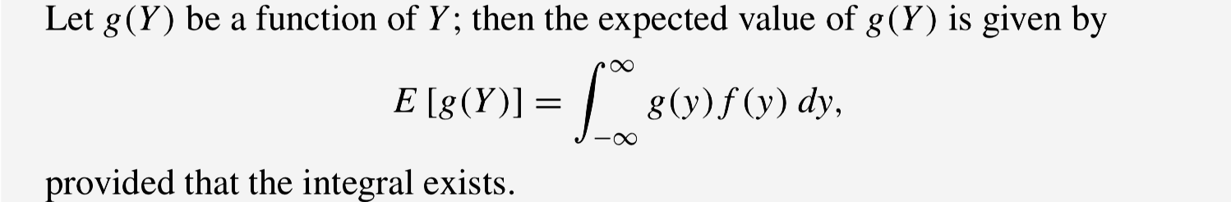

<Theorem 2>

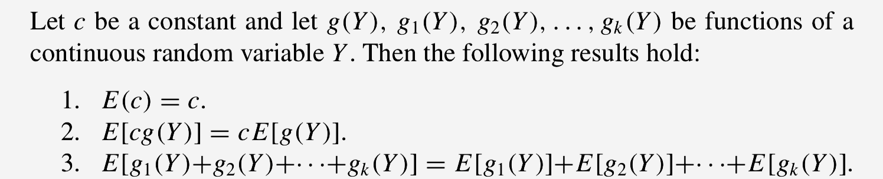  
 V(Y) = E(Y − μ)2 = E(Y2)−μ2

* 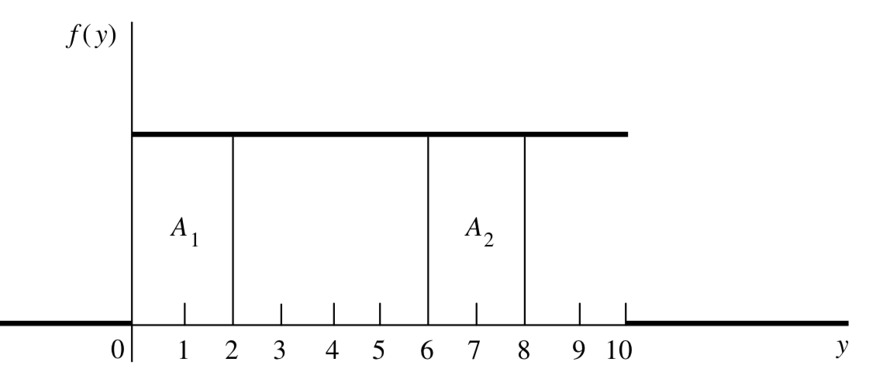4.4 The Uniform Probability Distribution

*If θ1 < θ2, a random variable Y is said to have a* ***continuous uniform probability distribution*** *on the interval (θ1, θ2) if and only if the density function of Y is*

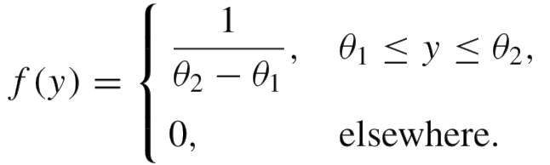

*The constants that determine the specific form of a density function are called parameters of the density function.*

Ex. Arrivals of customers at a checkout counter follow a Poisson distribution. It is known that, during a given 30-minute period, one customer arrived at the counter. Find the probability that the customer arrived during the last 5 minutes of the 30-minute period.

For example, suppose that the number of events, such as calls coming into a switchboard, that occur in the time interval (0, t ) has a Poisson distribution. If it is known that exactly one such event has occurred in the interval (0,t), then the actual time of occurrence is distributed uniformly over this interval.

The actual time of arrival follows a uniform distribution over the interval of (0, 30). If Y denotes the arrival time, then

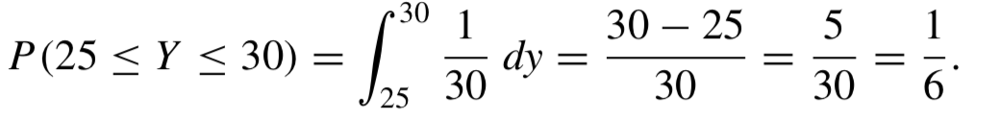

The probability of the arrival occurring in any other 5-minute interval is also 1/6.

<Theorem>

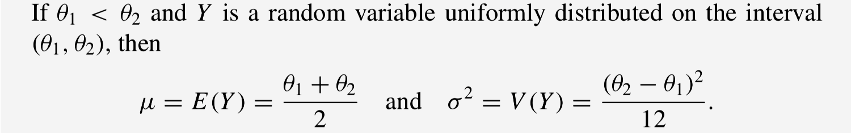

* 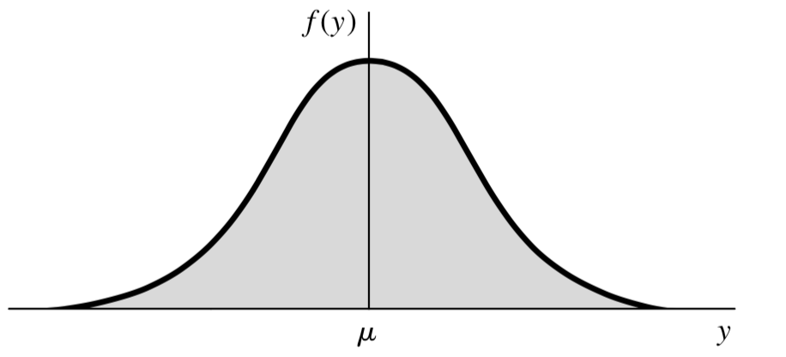4.5 The Normal Probability Distribution

A random variable Y is said to have a normal probability distribution if and only if, for σ >0 and −∞<μ<∞, the density function of Y is

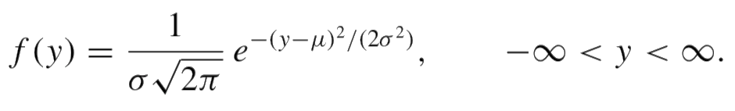

<Theorem>



*For the* ***standard normal random variable****, Z, its mean value is 0, and its standard deviation is 1.*

We can always transform a normal random variable Y to a standard normal random variable Z by using the relationship:

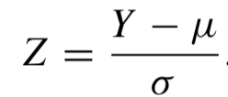

* 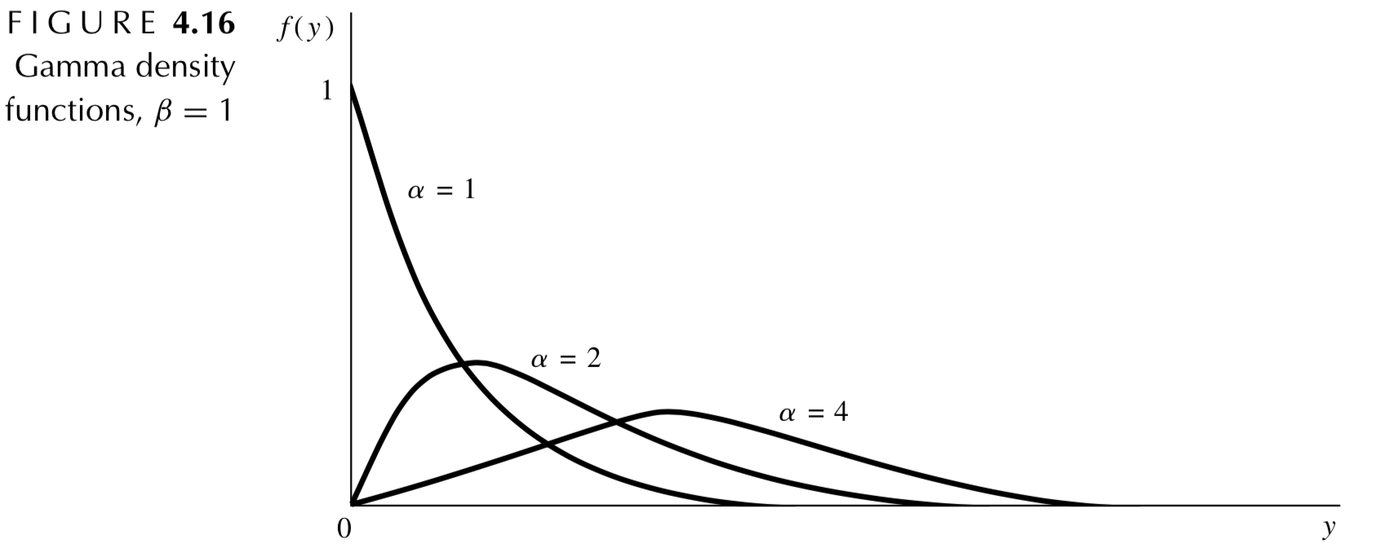4.6 The Gamma Probability Distribution

*A random variable Y is said to have a* ***gamma***

***distribution*** *with parameters α > 0 and β > 0*

*if and only if the density function of Y is*

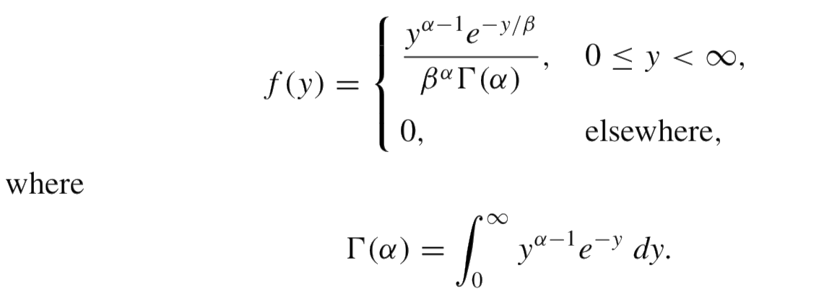

α is called the shape parameter.

β is called the scale parameter.

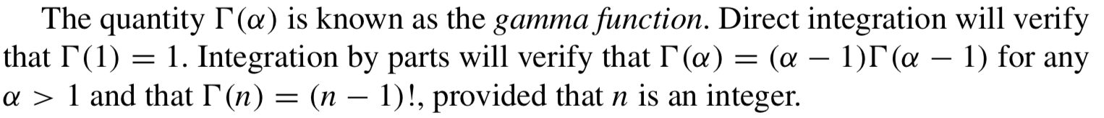

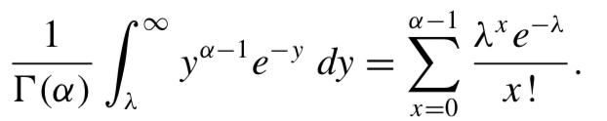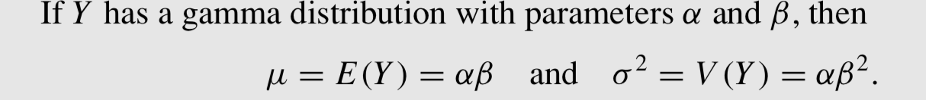

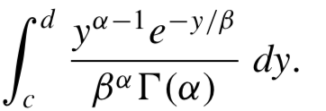When α is an integer, the distribution function of a gamma- distributed random variable can be expressed as a sum of certain Poisson probabilities.

If α is not an integer and 0 < c < d < ∞, it is impossible to give a closed-form expression for

As a result, except when α = 1 (an exponential distribution), it is impossible to obtain areas under the gamma density function by direct integration.

*Let ν be a positive integer. A random variable Y is said to have a* ***chi-square distribution with ν degrees of freedom*** *if and only if Y is a gamma-distributed random variable with parameters α = ν/2 and β = 2. (This random variable is called a* ***chi-square (χ 2 ) random variable****.)*

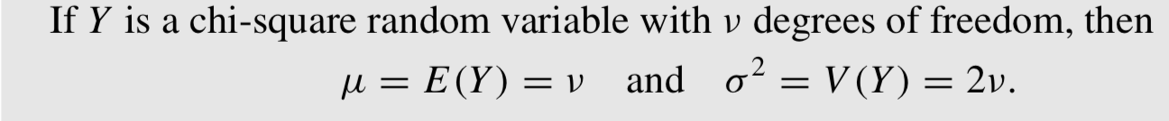

*A random variable Y is said to have an* ***exponential distribution*** *with parameter β > 0 if and only if the density function of Y is (α = 1)*

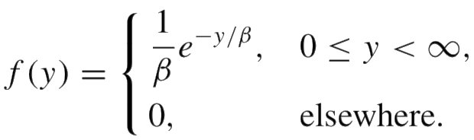

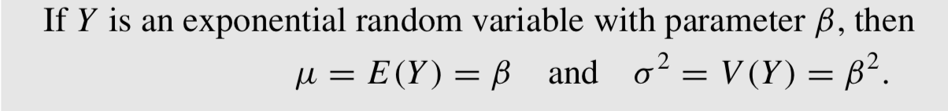

The exponential density function is often useful for modeling the length of life of electronic components. Suppose that the length of time a component already has operated does not affect its chance of operating for at least b additional time units. That is, the probability that the component will operate for more than a + b time units, given that it has already operated for at least a time units, is the same as the probability that a new component will operate for at least b time units if the new component is put into service at time 0.

Ex. Suppose that Y has an exponential probability density function. Show that, if a > 0 and b > 0,

P(Y > a + b|Y > a) = P(Y > b).

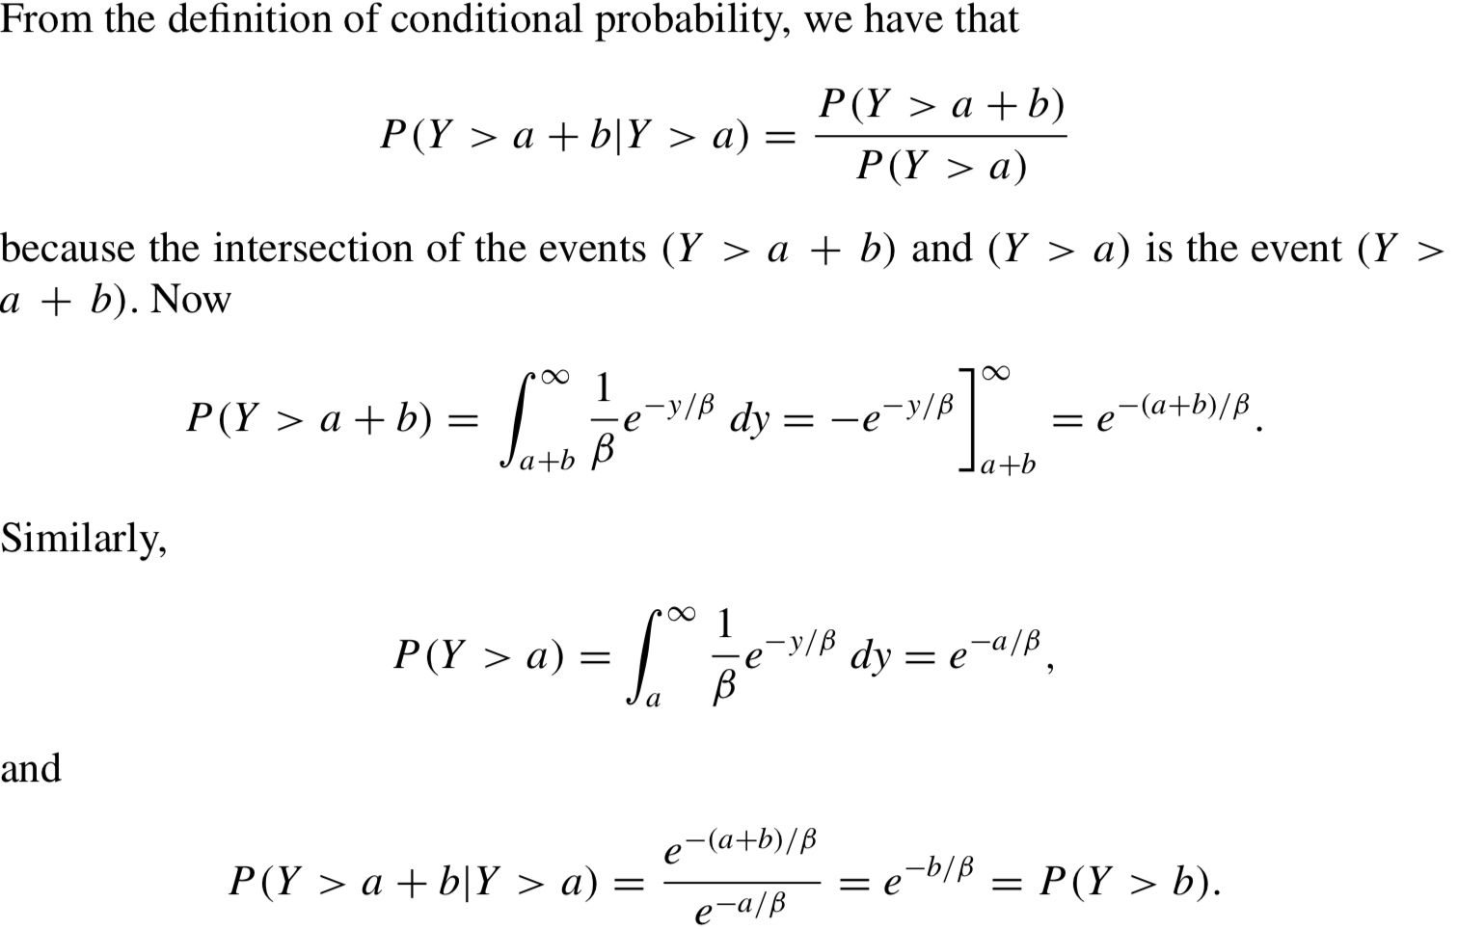

This property of the exponential distribution is called the memoryless property of the distribution.

Note that the geometric distribution, a discrete distribution, also has this memoryless property. And there is an interesting relationship between the exponential and geometric distribution.

Ex. Let Y be an exponentially distributed random variable with mean β. Define a random variable X in the following way: X = k if k − 1 ≤ Y < k for k = 1, 2, . . . .

a) Find P(X=k) for each k=1,2,....

b) Show that your answer to part (a) can be written as P(X=k)= (e−1/β )k−1 (1−e−1/β) , k=1, 2,...

and that X has a geometric distribution with p = (1 − e−1/β ) .

* 4.7 The Beta Probability Distribution

The beta density function is a two-parameter density function defined over the closed interval 0 ≤ y ≤ 1. It is often used as a model for proportions. Notice that defining y over the interval 0 ≤ y ≤ 1 does not restrict the use of the beta distribution. If c≤y≤d, then y∗ =(y−c)/(d−c)defines a new variable such that 0 ≤ y∗ ≤ 1.

*A random variable Y is said to have a* ***beta probability distribution with parameters α > 0 and β > 0*** *if and only if the density function of Y is*

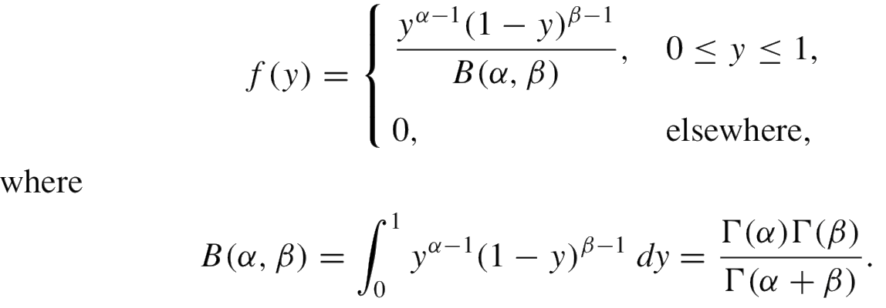

The graphs of beta density functions assume widely differing shapes for various values of α and β.

*The cumulative distribution function for the beta random variable is commonly called* ***the incomplete beta function*** *and is denoted by*

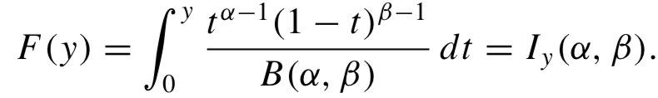

Note that when α and β are both positive integers, Iy(α,β) is related to the binomial probability function. Integration by parts can be used to show that for 0 < y < 1, and α and β both integers,

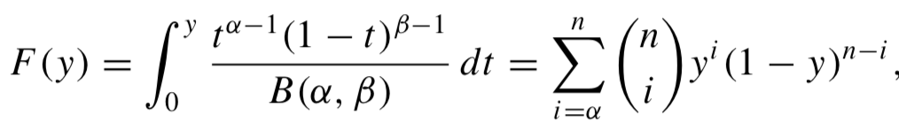

where n = α + β – 1, y=p.

<Theorem>

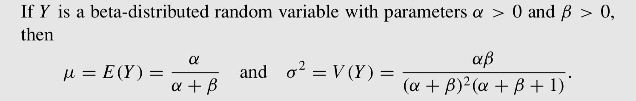

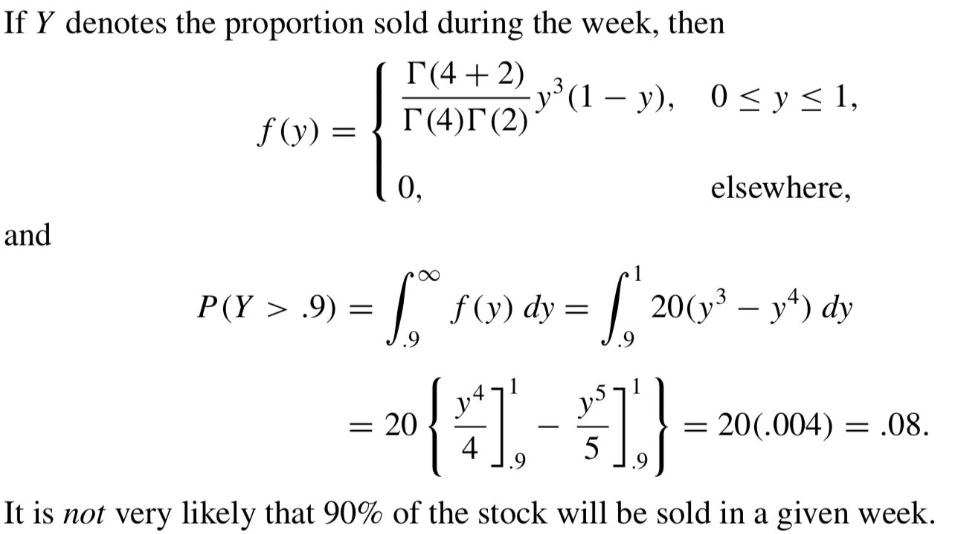Ex. A gasoline wholesale distributor has bulk storage tanks that hold fixed supplies and are filled every Monday. Of interest to the wholesaler is the proportion of this supply that is sold during the week. Over many weeks of observation, the distributor found that this proportion could be modeled by a beta distribution with α = 4 and β = 2. Find the probability that the wholesaler will sell at least 90% of her stock in a given week.

* 4.9 Other Expected Values

*If Y is a continuous random variable, then the* ***kth moment about the origin*** *is given by*

*μ’k =E(Yk), k=1,2,....*

*The* ***kth moment about the mean****, or the* ***kth central moment****, is given by*

*μk =E[(Y−μ)k], k=1,2,....*

Ex. Find μ’k for the uniform random variable with θ1 = 0 and θ2 = θ

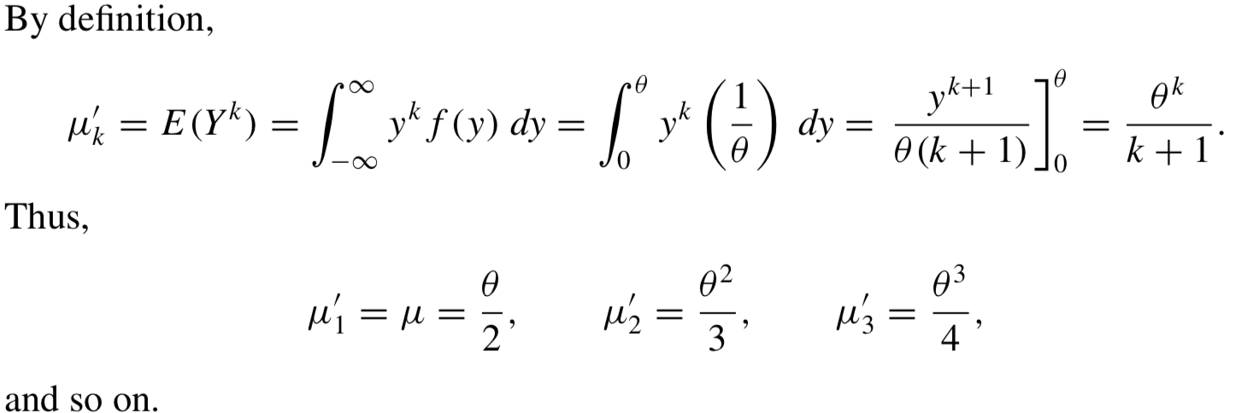

<Theorem>

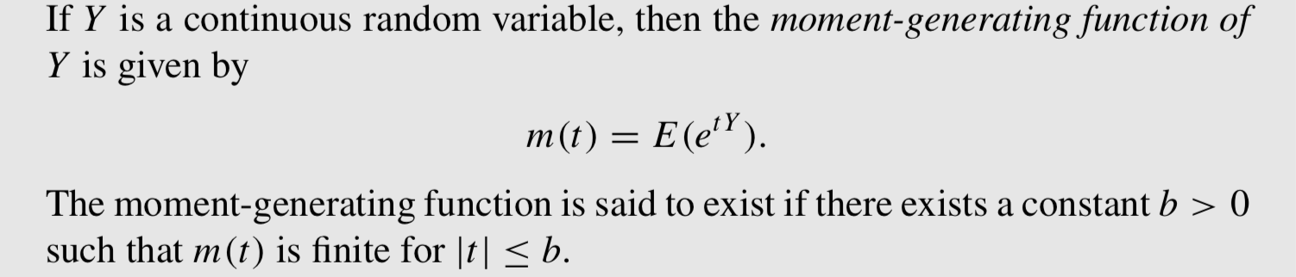

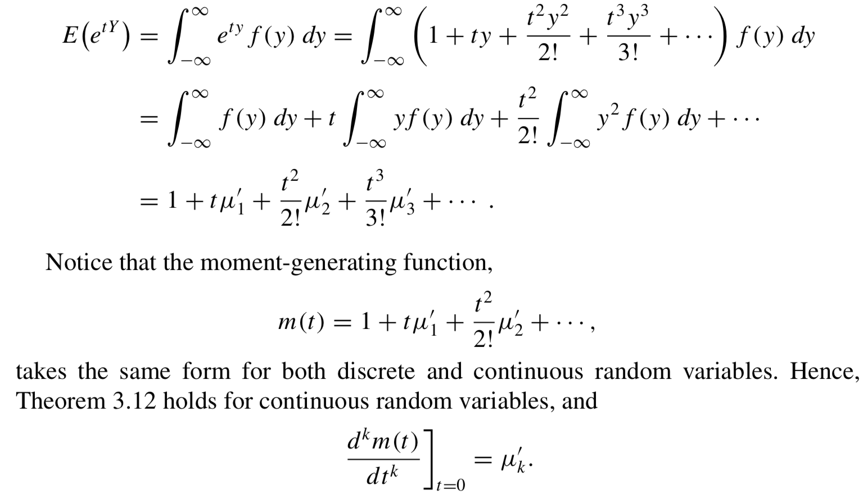

<Theorem>

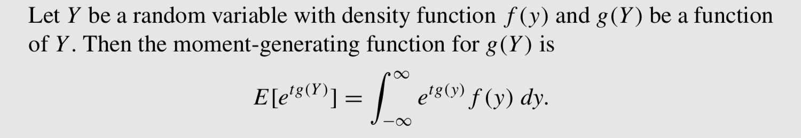

* 4.10 Tchebysheff’s Theorem

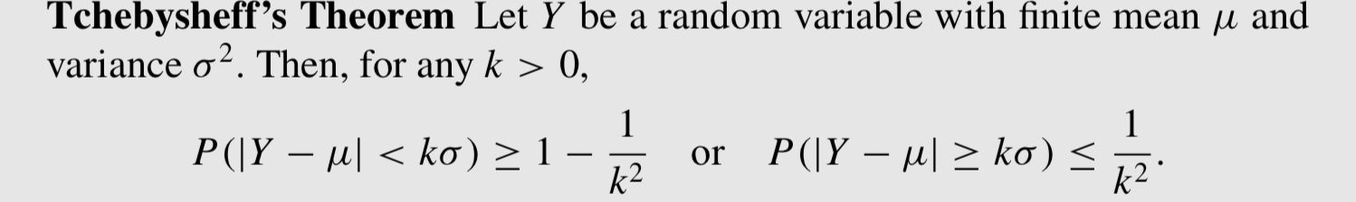

* 4.11 Expectations of Discontinuous Functions and Mixed Probability Distributions

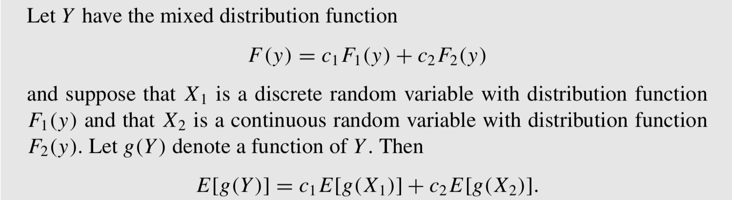

* 4.12 Summary

